The current design for the algorithms can be seen in the Appendices1 and can also be accessed by following the link attached there.

One of the main factors for the current algorithm approach of the artefact is the difficulty of implementation. By using simple algorithms, the implementation became much easier however once the data size increases over time there is a possibility that there would be a need to reconsider the approach and look for different ways. Another disadvantage of using these kinds of algorithms is the processing power required to carry out each task is increased and that would mean that the cost of maintenance for having a hosting service would be higher.

The second factor was the process of elimination. To reduce the data size the most effective way is to eliminate the largest data sets from the earliest of stages. For example, in the general search function by checking whether the user input is made of digits only, there is a possibility to check for whether it is an ISBN or not. If there is a match found with an ISBN in the data set it would mean that there was only needed to run a single set of Loops instead of going through the rest of loops.

For future implementation of the algorithms could consider to have a similarity check for words from user inputs to books so that if it finds a 100% match or close to 100% (book series) it would give those results back and stop the function after to speed the process up.

# References

Tori T. (May 13, 2020) *Choosing the Right Recommendation Algorithm* Available from: <https://www.advancinganalytics.co.uk/blog/2020/5/13/recommendation-systems> [accessed 05/02/2021]

Baptiste R. (Jun 3, 2019) *Introduction to recommender systems* Available from: <https://towardsdatascience.com/introduction-to-recommender-systems-6c66cf15ada> [accessed 05/02/2021]

Yasim, K. (Oct 30, 2018) *Approach to selecting the best algorithm for classification problems — A case study!* Available from: <https://medium.com/@yasimk_87248/approach-to-selecting-the-best-algorithm-for-classification-problems-a-case-study-7276bc19dd5d> [accessed 05/02/2021]

# Appendices1

Available from: <https://miro.com/app/board/o9J_leywbG4=/>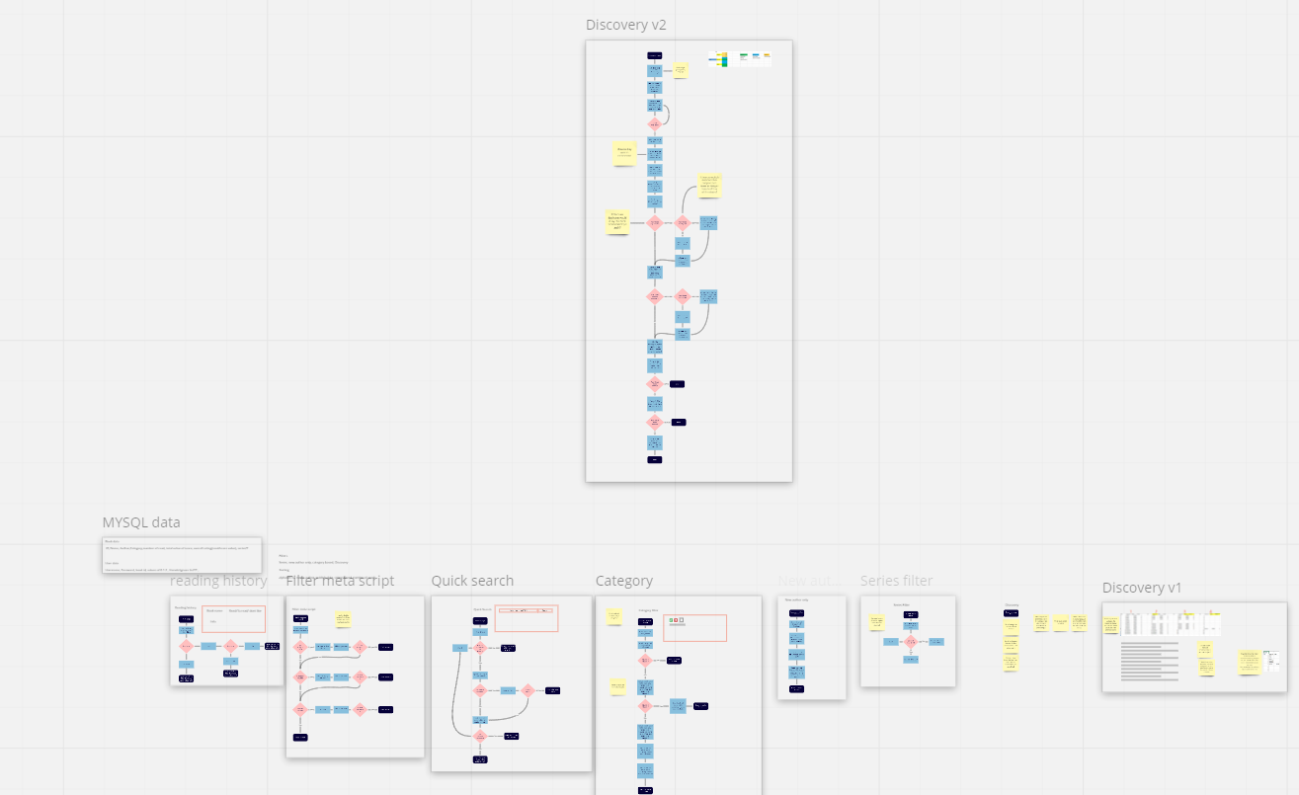 [accessed 26/04/2021]